Genesys Cloud Element Toolkit
Instruction Manual
- Launching the application
  - Locate the location where you downloaded or installed the Genesys Cloud Element Toolkit.
  - Double click the icon to launch the tool.
    - 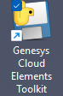
- Toolkit User Interface (UI)
  - 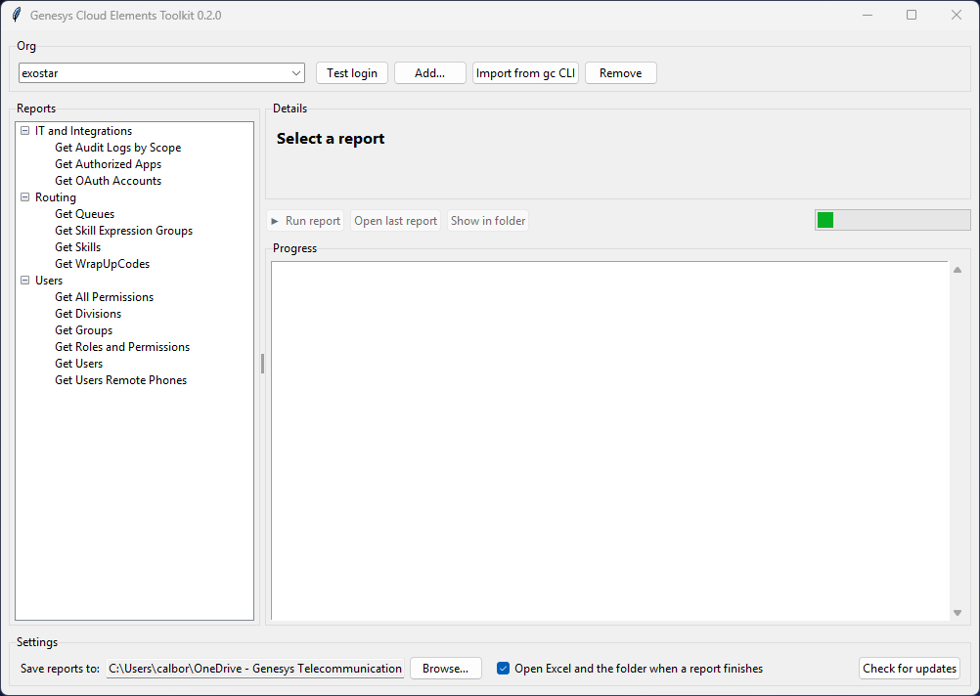

- Check installed current application version.
  - 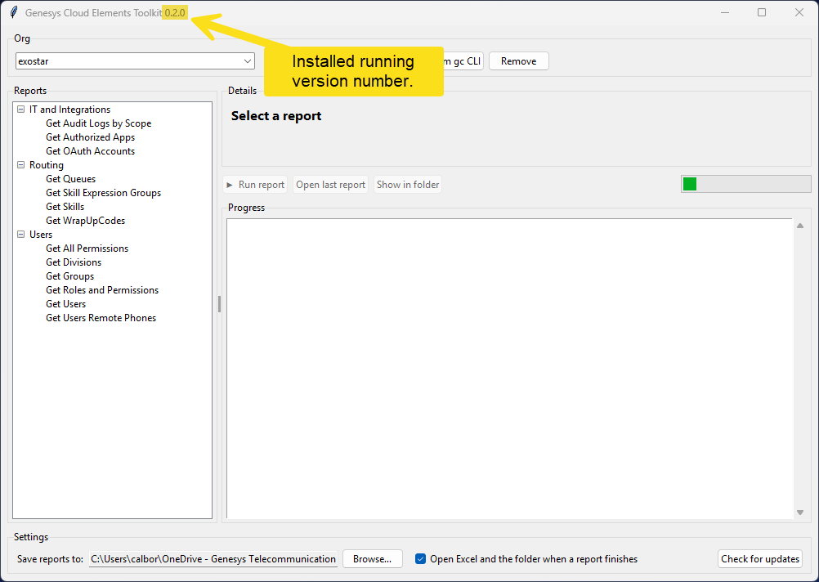

- How to check for application version updates.
  - 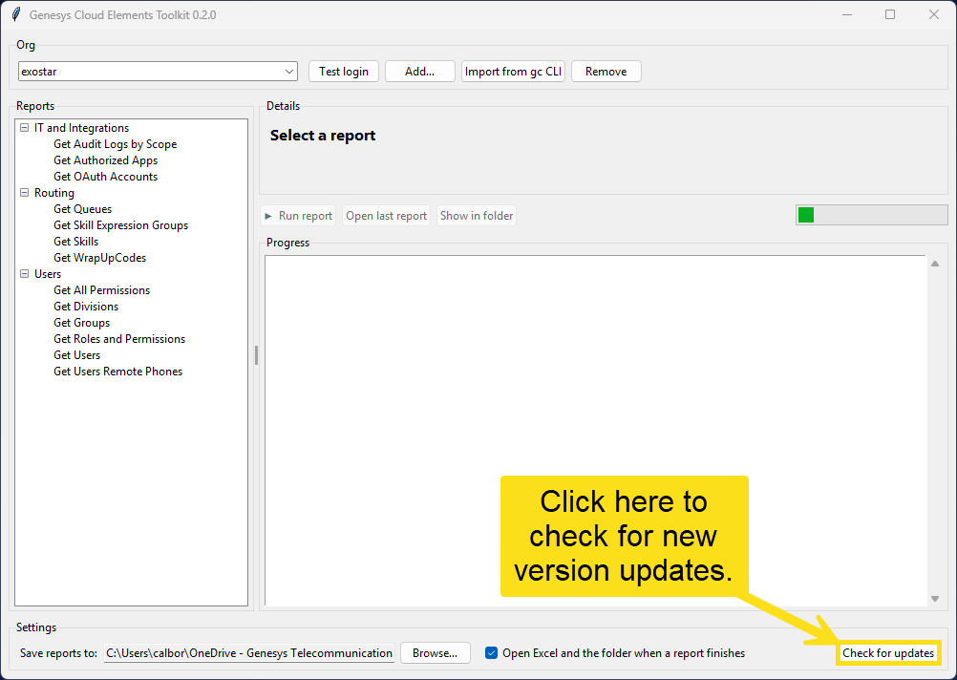

- Adding and removing Org Profiles
  - An org profile contains the orgs oAuth Client ID and Client Secret, along with the profile name and region.
  - To add a new org profile, follow the numbered steps below.
  - 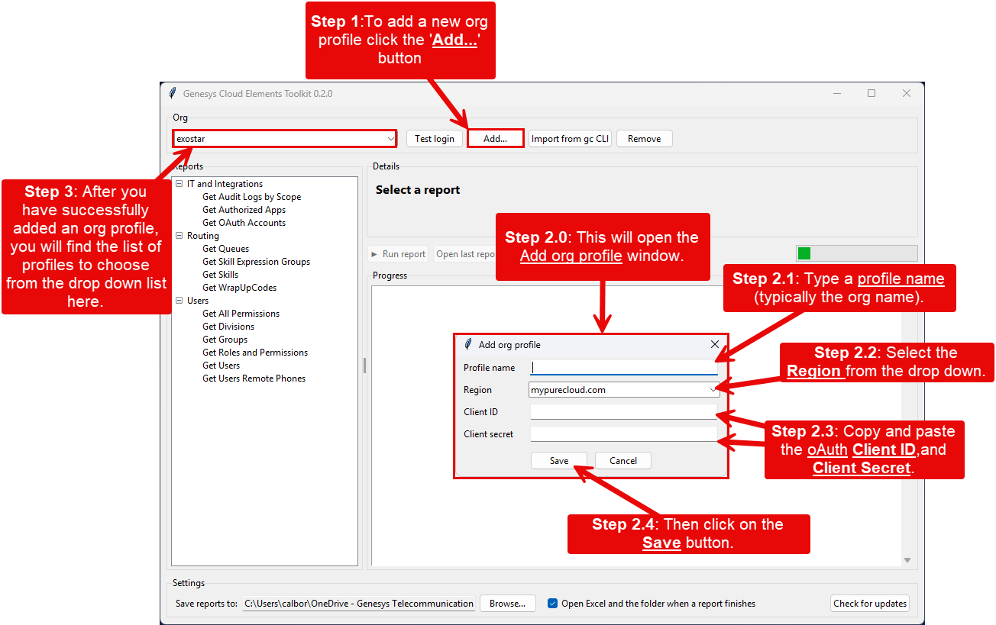

  - To remove an org profile, follow the numbered steps below.
  - 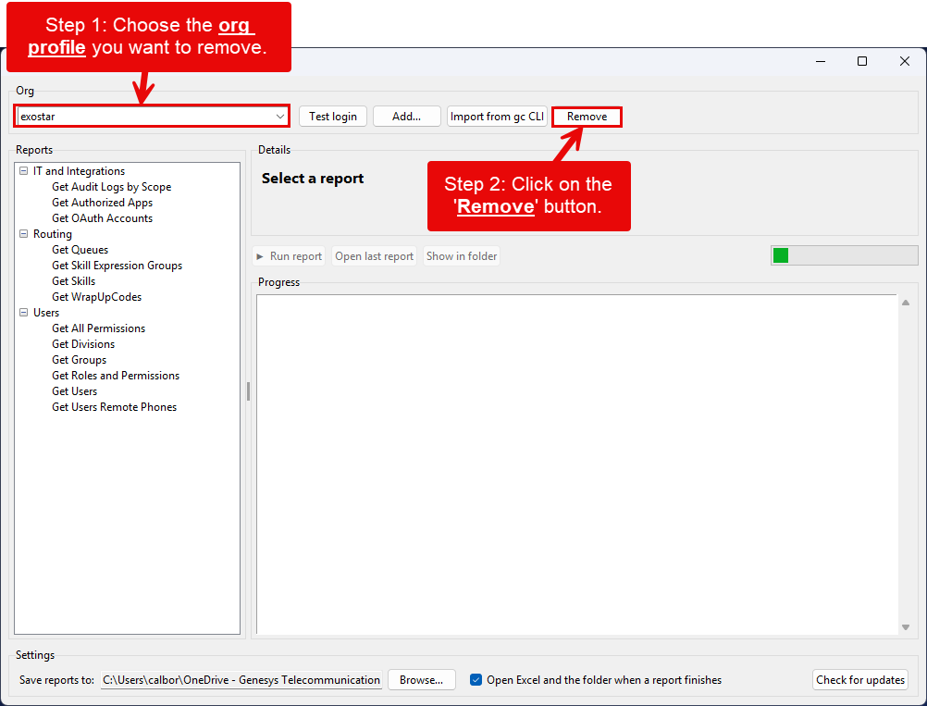

- If you previously used the GC.exe (GC CLI) tool to create org profiles, you could import them by using the button show below.
  - 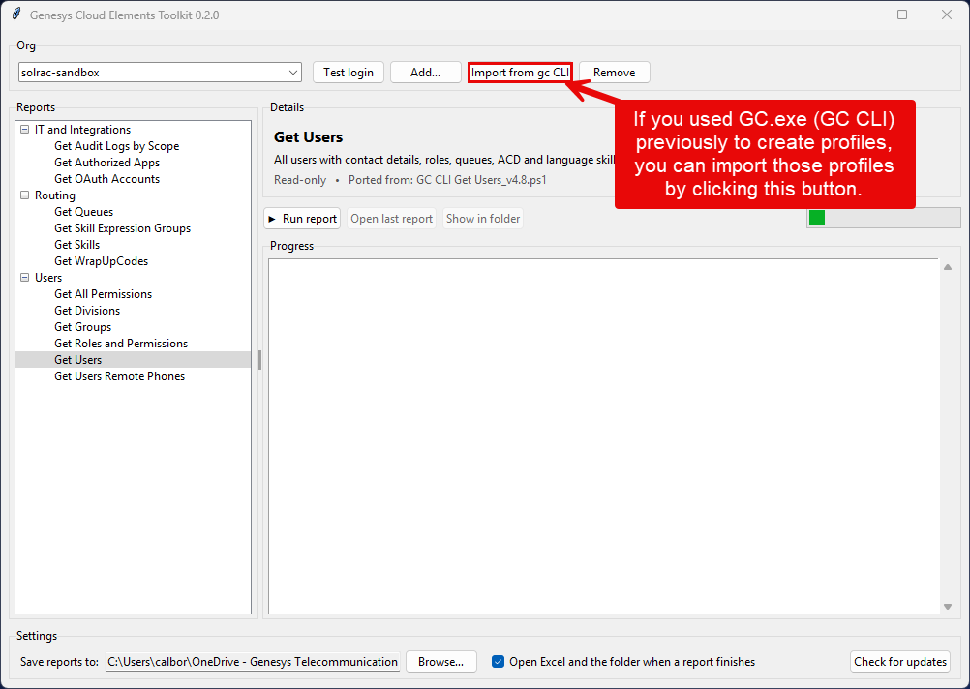

- To configure the exported report directory location and post report behavior follow these steps below.
  - 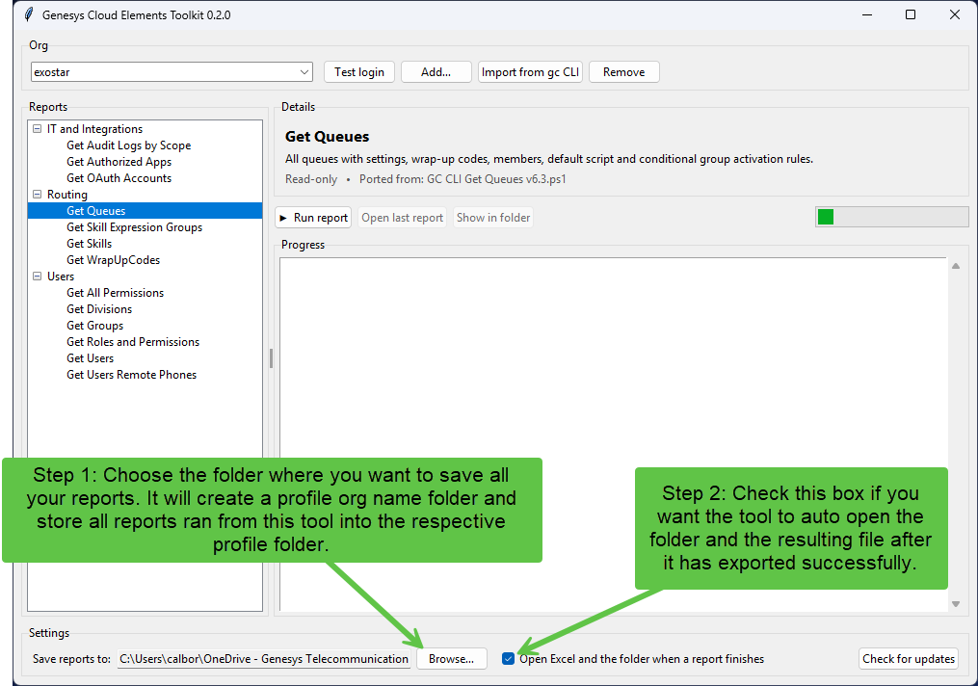

- To run a report, follow the steps below.
  - 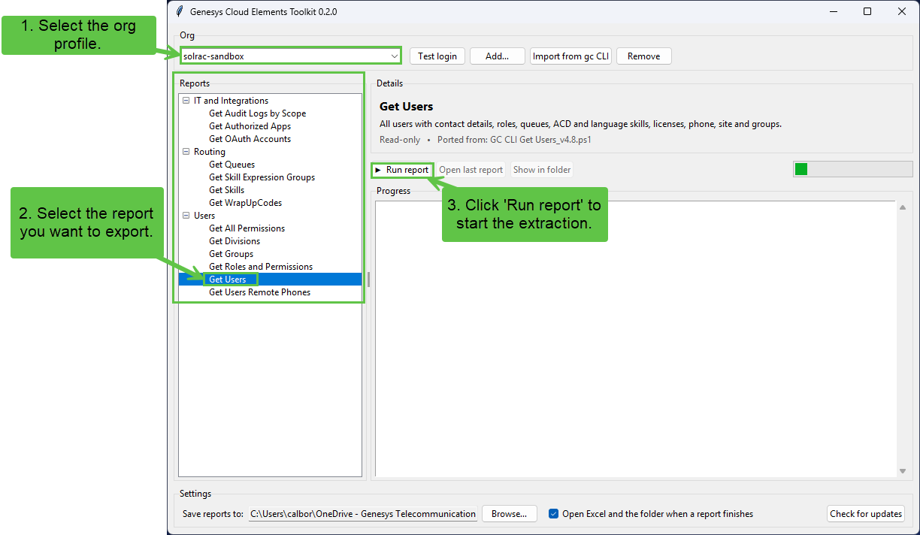

  - Report log and running status.
    - 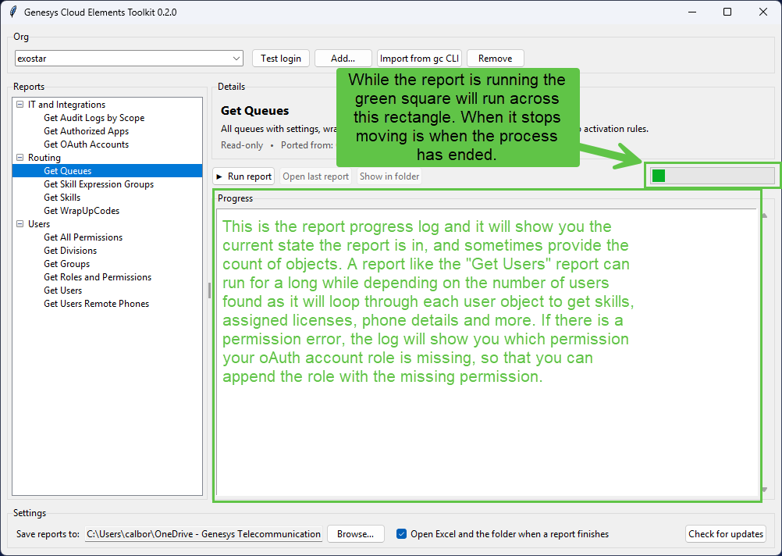

  - Here is an example of a successful “Get Users” report.
    - 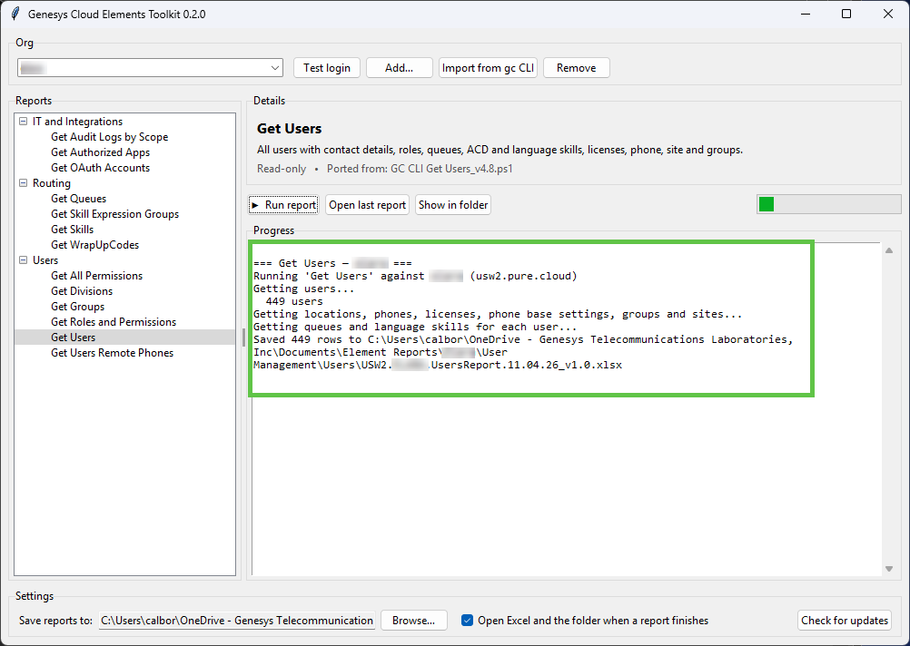

  - Post successful report options.
    - 

